HavestIQ – Data-Driven Crop Yield Prediction
A Project Report Submitted in
the partial fulfillment of the requirements for the award of the degree of

BACHELOR OF TECHNOLOGY
In

DEPARTMENT OF COMPUTER SCIENCE AND ENGINEERING
By
Pathi Sharmila | 2420030042
Sanivarapu Sadhana | 2420030225
Maddipatla Pavani Sree | 2420030336

Under the Esteemed Guidance of
Dr.N. SUNANDA

Associate Professor

Department of COMPUTER SCIENCE AND ENGINEERING

AY- 2026 - 2027

Semester: ODD SEMESTER




K L (Deemed to be) University
DEPARTMENT OF COMPUTER SCIENCE AND ENGINEERING

Declaration

The Project Report entitled “HarvestIQ – Data-Driven Crop Yield Prediction” is a record of Bonafide work of Pathi Sharmila - 2420030042, Sanivarapu Sadhana - 2420030225, Maddipatla Pavani Sree - 2420030336 submitted in partial fulfillment for the award of B. Tech in Computer Science and Engineering to the K L University. The results embodied in this report have not been copied from any other departments/University/Institute.

Pathi Sharmila - 2420030042
Sanivarapu Sadhana - 2420030225
Maddipatla Pavani Sree - 2420030336

K L (Deemed to be) University
DEPARTMENT OF COMPUTER SCIENCE AND ENGINEERING

CERTIFICATE

This is certify that the mini project-based report entitled “HarvestIQ – Data-Driven Crop Yield Prediction” is a Bonafide work done and submitted by Pathi Sharmila - 2420030042, Sanivarapu Sadhana - 2420030225, Maddipatla Pavani Sree - 2420030336 in partial fulfillment of the requirements for the award of the degree of BACHELOR OF TECHNOLOGY in Department of COMPUTER SCIENCE AND ENGINEERING, K L (Deemed to be University), during the academic year 2026-2027.

_____________________  Project Guide  Dr. N. Sunanda  Associate Professor, CSE | _____________________  Course Coordinator  Dr. N. Sunanda  Department of CSE | _____________________  Head of the Department  Dr.P. Venkateswara Rao  Department of CSE

ACKNOWLEDGEMENT
The success in this project would not have been possible but for the timely help and guidance rendered by many people. Our wish to express my sincere thanks to all those who have assisted us in one way or the other for the completion of my project.

Our greatest appreciation to my Course Coordinator and my guide Dr.N. SUNANDA, Department of COMPUTER SCIENCE AND ENGINEERING, which cannot be expressed in words for his/her tremendous support, encouragement and guidance for this project.

We express our gratitude to Dr.Venkateshwar Rao, Head of the Department of Computer Science and Engineering, for providing us with adequate facilities, ways and means by which we can complete this project-based Lab.

We thank all the members of teaching and non-teaching staff members, and also who have assisted me directly or indirectly for successful completion of this project. Finally, I sincerely thank my parents, friends and classmates for their kind help and cooperation during my work.

Pathi Sharmila - 2420030042
Sanivarapu Sadhana - 2420030225
Maddipatla Pavani Sree - 24200300336

Abstract
Agriculture faces several challenges in accurately predicting crop yield due to variations in rainfall, temperature, soil quality, fertilizer usage, crop type, and regional conditions. Traditional methods often rely on historical data and manual estimation, which may not effectively capture changing agricultural and environmental factors.
Existing crop yield prediction approaches use statistical and machine learning techniques to analyze agricultural and environmental data. Models such as Linear Regression, Decision Trees, Random Forest, and Support Vector Regression have been widely used to estimate crop productivity based on historical agricultural information.
The proposed system aims to predict crop yield using three machine learning algorithms: Linear Regression, Decision Tree Regressor, and Random Forest Regressor. The dataset undergoes data preprocessing, Exploratory Data Analysis (EDA), feature engineering, and model evaluation. Model performance is measured using Mean Absolute Error (MAE), Root Mean Squared Error (RMSE), and R² score. The prediction results are presented through an interactive dashboard, enabling better visualization and understanding of crop yield patterns.
In the future, the system can be enhanced by incorporating real-time weather data, soil nutrients, irrigation information, satellite imagery, and pest or disease-related data. Advanced machine learning and deep learning techniques can also be integrated to improve prediction accuracy and provide more effective agricultural recommendations.
Index
S. No. | Chapters | Topics | Page.no
 |  | Acknowledgement
 |  | Abstract
1 | Introduction | 1.1 Background  1.2 Problem Statement  1.3 Objectives  1.4 Scope  1.5 Importance and Applications | 1-10
2 | Literature Survey | 2.1 Review of Related Studies  2.2 Comparative Analysis  2.3 Research Gaps | 11-20
3 | System Requirements and Technology Stack | 3.1 Hardware Requirements  3.2 Software Requirements  3.3 Technologies, Libraries and Development Tools | 21-30
4 | Proposed Methodology and System Architecture | 4.1 Proposed System  4.2 Dataset Description  4.3 System Architecture  4.4 Data Preprocessing  4.5 EDA  4.6 Feature Engineering and Selection  4.7 Model Development and Evaluation | 31-35
5 | System Design and Implementation | 5.1 Overall Workflow  5.2 Module-wise Implementation  5.3 Machine Learning Pipeline  5.4 Stacking Ensemble Architecture  5.5 Streamlit Dashboard Implementation | 36-42
6 | Features and Functionalities | 6.1 Project Overview  6.2 EDA Visualizations  6.3 Crop Yield Prediction  6.4 Model Evaluation  6.5 Dataset Insights  6.6 CSV Report Download | 43-55
7 | Results and Testing | 7.1 Experimental Setup  7.2 Evaluation Metrics  7.3 Model Performance Comparison  7.4 Prediction Results  7.5 Testing and Validation | 56-60
8 | Challenges and Limitations | 8.1 Challenges Faced  8.2 Solutions Applied  8.3 Current Limitations | 61-67
9 | Future Scope | 9.1 Dataset Expansion  9.2 Advanced ML Techniques  9.3 Real-Time Integration  9.4 Dashboard Enhancements | 68-73
10 | Conclusion | 10.1 Project Summary  10.2 Achievements  10.3 Skills Learned | 74-80
11 | References | Research papers
12 | Appendices | Dashboard screenshots  Important graphs  Code snippets  Installation and user guide

CHAPTER 1
Introduction
1.1 Background of the Project
Agriculture is an important sector that contributes to food production and economic development. Crop yield depends on several factors, including soil nutrients, moisture, temperature, rainfall, humidity, and farming practices. Predicting crop yield accurately can help improve agricultural planning and productivity.
Traditional yield estimation methods often rely on experience and historical observations. However, machine learning provides a data-driven approach to identifying patterns among agricultural and environmental factors.
This project focuses on developing a machine learning-based system to predict crop yield using agricultural and environmental data. It includes data preprocessing, exploratory data analysis, feature engineering, feature selection, model development, and evaluation. An interactive Streamlit dashboard is also developed to allow users to explore the dataset and generate crop yield predictions.
1.2 Problem Statement
Crop yield is influenced by multiple agricultural and environmental factors, making accurate estimation a challenging task. Traditional prediction methods may not effectively capture relationships among these factors.
The problem addressed in this project is to develop a machine learning-based system that uses agricultural and environmental attributes to predict crop yield. The system aims to analyze historical data, identify relevant features, compare different regression models, and provide reliable yield estimates through an interactive dashboard.
1.3 Objectives of the Project
The main objective of this project is to develop a machine learning-based system that predicts crop yield using agricultural and environmental factors. The project focuses on analyzing relevant data, identifying important features, developing predictive models, and providing an interactive platform for generating predictions.
The specific objectives are:
- To preprocess and analyze agricultural and environmental data relevant to crop yield prediction.
- To identify and select the most influential features affecting crop yield through exploratory data analysis and feature selection techniques.
- To develop and compare machine learning regression models for accurate crop yield prediction.
- To evaluate and select the best-performing model using appropriate performance metrics such as MAE, RMSE, and R².
- To develop a simple and user-friendly dashboard for crop yield prediction and visualization of important agricultural insights.
1.4 Scope of the Project
The scope of this project is to develop a machine learning-based crop yield prediction system using agricultural and environmental factors. The system uses a structured dataset containing information about soil properties, nutrients, weather conditions, crop types, and farming practices to estimate crop yield.
The project covers the following areas:
- Data Analysis: Examining agricultural data to identify patterns, trends, and relationships between input variables and crop yield.
- Data Preprocessing: Preparing the dataset through missing-value handling, categorical encoding, and numerical feature scaling.
- Feature Engineering and Selection: Creating meaningful features and selecting relevant variables to improve the predictive process.
- Machine Learning: Developing and comparing multiple regression models, including a stacking ensemble model, to predict crop yield.
- Model Evaluation: Assessing the performance of trained models using standard regression evaluation metrics.
- Interactive Dashboard: Providing a Streamlit-based interface for dataset exploration, model evaluation, and crop yield prediction.
- Prediction Reports: Allowing users to download generated prediction results in CSV format.
The current implementation focuses on predictions using the available dataset and its attributes. It does not include real-time sensor integration, live weather data collection, or direct deployment in agricultural fields.
1.5 Importance and Applications
Crop yield prediction is important for improving agricultural planning and supporting informed farming decisions. By analyzing agricultural and environmental factors, machine learning models can provide estimates of expected crop production and help users understand the factors associated with crop yield.
The major importance and applications of this project include:
1. Agricultural Planning: Helps estimate expected crop yield, supporting better planning of farming activities and resource allocation.
2. Data-Driven Decision-Making: Uses historical agricultural data and machine learning techniques to provide predictions based on multiple input factors.
3. Understanding Agricultural Factors: Helps analyze how soil nutrients, moisture, temperature, rainfall, and other conditions relate to crop yield.
4. Model Performance Comparison: Demonstrates how different regression algorithms perform on the same crop yield prediction task.
5. Farmer and Research Support: Provides a platform that can support agricultural students, researchers, and other users in exploring crop-related data and understanding yield predictions.
6. Interactive Analysis: The Streamlit dashboard makes dataset visualizations, model evaluation results, and prediction functionality accessible through a user-friendly interface.
Overall, the project demonstrates the potential of machine learning in agricultural data analysis and crop yield estimation.

CHAPTER 2
LITERATURE SURVEY
2.1 Review of Related Studies
Several studies have explored the application of machine learning and deep learning techniques for crop yield prediction. These studies demonstrate how agricultural and environmental data can be used to identify patterns and estimate crop productivity.
Van Klompenburg et al. [7], Jabed and Murad [6], and Shawon et al. [8] presented literature reviews covering machine learning and deep learning approaches for crop yield prediction. Their work highlights the growing importance of data-driven techniques in agricultural forecasting.
Several researchers have investigated feature selection and model comparison to improve prediction performance. Maya Gopal and Bhargavi [13], [14] explored approaches for efficient crop yield prediction and the evaluation of feature subsets. Boppudi and Jayachandran [15] investigated hybrid feature-ranking techniques, while Joshua et al. [10] examined different machine learning approaches for crop yield prediction.
Other studies have focused on advanced machine learning and deep learning techniques. Wang et al. [16] reviewed developments in deep learning-based crop yield prediction, while Muruganantham et al. [17] examined the use of deep learning and remote sensing in agricultural prediction.
The integration of environmental and satellite-based information has also received attention. Studies such as those by Kumar et al. [20], Nevavuori et al. [21], and Shammi et al. [22] explored the use of UAV and multispectral imagery for crop-related prediction tasks.
Additionally, Hu et al. [18] highlighted the importance of explainable AI and interpretable machine learning in understanding crop yield predictions. Research by Wolpert [30] on stacked generalization also provides a foundation for ensemble learning approaches that combine multiple predictive models.
These studies provide a foundation for the present project, which focuses on preprocessing agricultural data, engineering and selecting relevant features, comparing multiple regression algorithms, and implementing a stacking ensemble model for crop yield prediction.
2.2 Comparative Analysis
The reviewed research papers demonstrate different approaches to crop yield prediction, including conventional machine learning, hybrid feature selection, boosting algorithms, deep learning, and the integration of environmental and satellite data.
The following table compares selected studies based on their approaches, identified limitations, and their relevance to the proposed project.
No. | Research Paper (Year) | Approach / Focus | Identified Limitation | Gap Addressed by Our Project
1 | A Proposed Framework for Crop Yield Prediction Using Hybrid Feature Selection Approach and Optimized Machine Learning (2024) | Hybrid feature selection and optimized Support Vector Regression. | Involves multiple selection and optimization stages, increasing implementation complexity. | Implements feature selection and compares multiple regression models within a structured pipeline.
2 | Boosting Enabled Efficient Machine Learning Technique for Accurate Prediction of Crop Yield Towards Precision Agriculture (2024) | Boosting-based machine learning for crop yield prediction. | Greater emphasis on boosting approaches, leaving scope for broader model comparison. | Evaluates multiple conventional regression models alongside a stacking ensemble.
3 | Accurate Wheat Yield Prediction Using Machine Learning and Climate-NDVI Data Fusion (2024) | Combines climate and satellite-derived NDVI information for wheat yield prediction. | Requires integration of different data sources and specialized environmental information. | Uses a single agricultural dataset containing multiple crop, soil, and environmental attributes.
4 | Predicting Potato Crop Yield with Machine Learning and Deep Learning for Sustainable Agriculture (2024/2025) | Explores machine learning and deep learning architectures for potato yield prediction. | Focuses on a specific crop and explores computationally intensive approaches. | Develops a practical prediction pipeline using multiple regression algorithms on a dataset containing different crop types.
5 | Comparative Analysis of Machine Learning and Statistical Models for Cotton Yield Prediction in Major Growing Districts of Karnataka, India (2025) | Compares statistical and machine learning models for cotton yield prediction. | Focuses on a specific crop and selected geographical districts. | Explores crop yield prediction using multiple agricultural and environmental attributes across different crop types.
Comparative analysis highlights the importance of developing a structured prediction pipeline that combines data preprocessing, feature engineering, feature selection, model comparison, and ensemble learning. The proposed project addresses these aspects through an integrated machine learning workflow and an interactive Streamlit dashboard.
2.3 Research Gaps
Based on the literature survey and comparative analysis, several areas have been identified for further exploration in crop yield prediction:
1. Limited Integration of Prediction Workflow: Some approaches focus mainly on individual stages, such as feature selection or model optimization, rather than presenting a complete workflow from data preprocessing to prediction.
2. Need for Model Comparison: There is scope for evaluating multiple regression algorithms under a common experimental setup to understand their relative performance.
3. Feature Representation: Identifying and engineering meaningful features from existing agricultural and environmental attributes can provide additional information for prediction.
4. Ensemble Learning: Combining different regression algorithms through stacking provides an opportunity to explore whether an ensemble can improve predictive performance compared with individual models.
5. Practical Accessibility: There is a need to make prediction systems accessible through interactive interfaces that support data exploration, model evaluation, and user-input-based predictions.
To address these gaps, the proposed project develops an integrated crop yield prediction workflow that includes preprocessing, exploratory data analysis, feature engineering, feature selection, comparison of ten regression models, and a stacking ensemble approach. A Streamlit dashboard is also implemented to provide an accessible interface for exploring data and generating crop yield predictions.

CHAPTER 3
SYSTEM REQUIREMENTS AND TECHNOLOGY STACK
3.1 Hardware Requirements
The following hardware requirements are suitable for developing and running the Crop Yield Prediction project.
Component | Minimum Requirement
Processor | Intel Core i3 or equivalent
RAM | 8 GB
Storage | 5 GB of available space
Operating System | Windows 10 or later
Display | Standard monitor with minimum 1366 × 768 resolution
Internet Connection | Required for installing libraries and accessing online resources
The project can be done on a standard personal computer. A system with higher RAM and processing capacity is recommended for smoother execution of machine learning algorithms and the Streamlit dashboard.
3.2 Software Requirements
The following software and tools were used for developing and executing the Crop Yield Prediction project.
Software / Tool | Purpose
Operating System | Windows 10/11
Programming Language | Python
Development Environment | Visual Studio Code
Notebook Environment | Jupyter Notebook
Dashboard Framework | Streamlit
Dataset Format | CSV
Model Serialization | Joblib
Python Libraries:
- Pandas and NumPy: Used for data manipulation, preprocessing, and numerical computations.
- Matplotlib and Seaborn: Used to create visualizations for exploratory data analysis.
- Scikit-learn: Used for preprocessing, feature selection, model development, and evaluation.
- CatBoost: Used for implementing the CatBoost regression model.
- Streamlit: Used to develop the interactive web dashboard.
- Joblib: Used to save and load trained models and preprocessing objects.
These software tools and libraries provide the necessary environment for implementing the complete crop yield prediction workflow.
3.3 Technologies, Libraries and Development Tools
The following technologies and tools were used in the development of the Crop Yield Prediction system:
- Programming Language: Python
- Development Environment: Visual Studio Code and Jupyter Notebook
- Data Processing: Pandas and NumPy
- Data Visualization: Matplotlib and Seaborn
- Machine Learning: Scikit-learn and CatBoost
- ML Models: Linear Regression, Decision Tree, Random Forest, Support Vector Regression, K-Nearest Neighbors, Gradient Boosting, HistGradientBoosting, Extra Trees, CatBoost, and Stacking Regressor.
- Feature Selection: SelectKBest and Recursive Feature Elimination (RFE).
- Model Evaluation: MAE, MSE, RMSE, and R² Score.
- Dashboard Development: Streamlit
- Model Serialization: Joblib
- Dataset Source: Kaggle
These technologies were selected to support the complete project workflow, from data preparation and model development to evaluation and interactive prediction.

CHAPTER 4
PROPOSED METHODOLOGY AND SYSTEM ARCHITECTURE

4.1 Proposed System
The proposed system is a machine learning-based crop yield prediction application that estimates crop yield using agricultural and environmental factors. It uses a structured dataset containing information about soil nutrients, soil properties, weather conditions, crop types, and farming practices.
The system follows a systematic workflow consisting of data preprocessing, exploratory data analysis, feature engineering, feature selection, model development, and performance evaluation. Ten regression models are implemented and compared to identify the best-performing model. A stacking ensemble model is also developed by combining Linear Regression, Random Forest, and Gradient Boosting as base models, with Ridge Regression as the final estimator.
The trained model and preprocessing components are saved for reuse in the prediction application. A Streamlit dashboard provides an interactive interface where users can explore dataset visualizations, examine model performance, enter agricultural details, and obtain crop yield predictions.
The proposed system aims to provide an integrated and user-friendly approach to agricultural data analysis and crop yield estimation.

4.2 Dataset Description
The project uses a crop yield dataset obtained from Kaggle, containing 10,000 records and 20 columns. The dataset includes agricultural and environmental information that can influence crop productivity.
The dataset consists of 19 input features and one target variable, Crop_Yield_ton_per_hectare, which represents the crop yield to be predicted.

Dataset attributes:
Category | Attributes
Soil Nutrients | N, P, K
Soil Properties | Soil_pH, Soil_Moisture, Soil_Type, Organic_Carbon
Environmental Factors | Temperature, Humidity, Rainfall, Sunlight_Hours, Wind_Speed, Altitude
Agricultural Factors | Region, Season, Crop_Type, Irrigation_Type, Fertilizer_Used, Pesticide_Used
Target Variable | Crop_Yield_ton_per_hectare
Dataset Overview:
- Total records: 10,000
- Total columns: 20
- Input features: 19
- Target variable: 1
- Data format: CSV
The dataset provides a combination of numerical and categorical attributes, making it suitable for applying data preprocessing, feature engineering, feature selection, and machine learning techniques for crop yield prediction.

4.3 System Architecture
The system architecture illustrates the overall structure and workflow of the Crop Yield Prediction application. It consists of multiple stages, beginning with dataset input and ending with crop yield prediction through an interactive dashboard.
The architecture is organized into the following stages:
- Dataset Input: The agricultural dataset is collected from Kaggle in CSV format.
- Data Preprocessing: Missing values are handled, categorical variables are encoded, and numerical features are scaled.
- Exploratory Data Analysis: Statistical analysis and visualizations are performed to understand the dataset and identify relationships between variables.
- Feature Engineering and Selection: Six additional features are created, and relevant features are selected using SelectKBest and RFE.
- Model Development: Multiple regression algorithms are trained and evaluated, including a stacking ensemble model.
- Model Evaluation: Models are compared using MAE, MSE, RMSE, and R² Score.
- Prediction Application: The saved model and preprocessing components are integrated into the Streamlit dashboard.
- Output: Users receive predicted crop yield along with visual insights and downloadable prediction reports.
The architecture provides a structured flow connecting data preparation, machine learning, model evaluation, and interactive prediction.

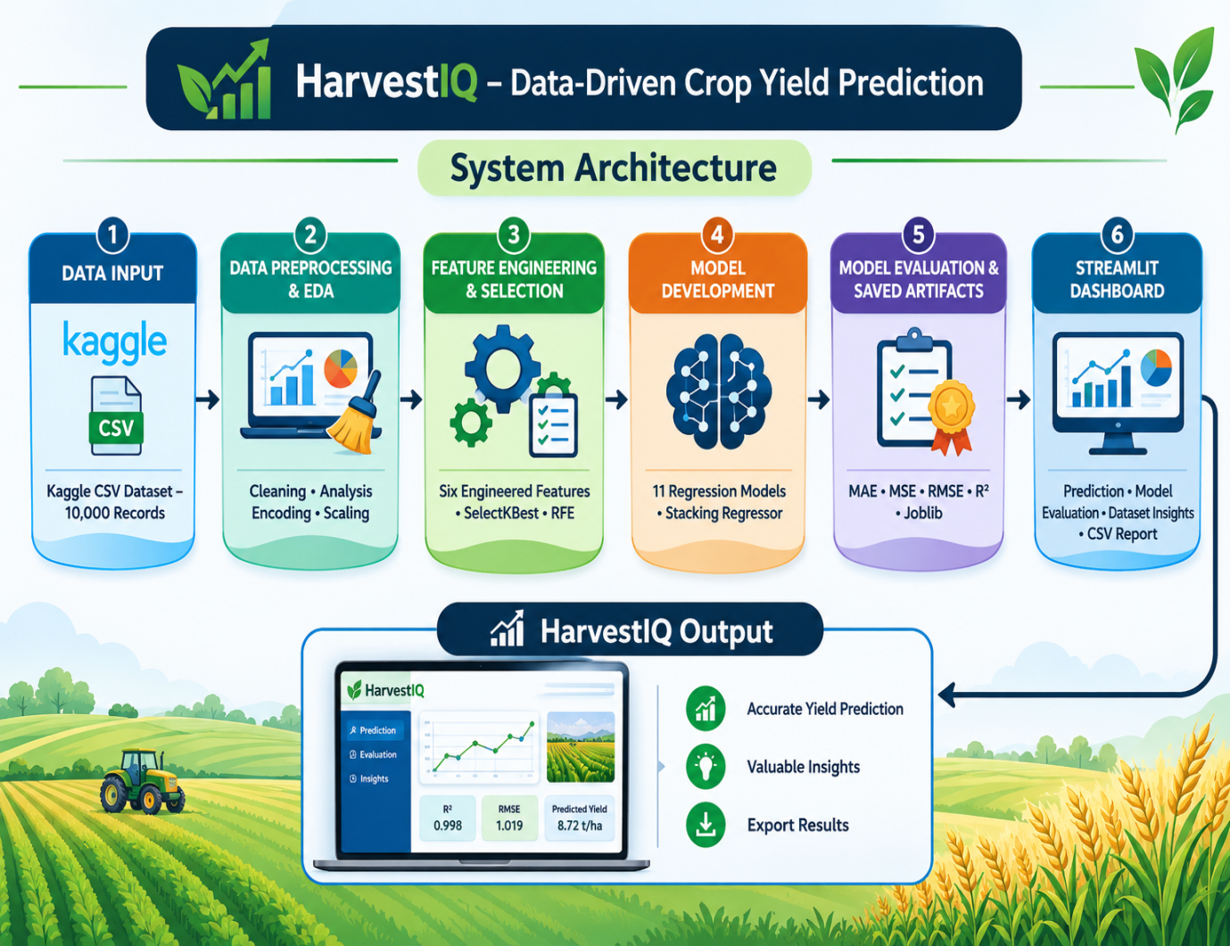

4.4 Data Preprocessing
Data preprocessing is an important step in preparing the agricultural dataset for machine learning. It ensures that the input data is properly structured and suitable for model training and prediction.
The following preprocessing techniques were applied in this project:
1. Missing Value Handling: Missing numerical values were handled using median imputation, while missing categorical values were handled using the most frequent value.
2. Categorical Encoding: Categorical attributes were converted into numerical representations using One-Hot Encoding with handle_unknown='ignore'.
3. Feature Scaling: Numerical features were standardized using StandardScaler to bring them onto a comparable scale.
4. Training and Testing Split: The dataset was divided into 80% training data and 20% testing data to train and evaluate the models.
5. Preprocessing Pipeline: A ColumnTransformer was used to apply the appropriate preprocessing techniques to numerical and categorical features.
The preprocessing pipeline was fitted using only the training data, while the test data was transformed using the fitted pipeline. This helped prevent data leakage and ensured consistent preprocessing during model evaluation and future predictions.

4.5 Exploratory Data Analysis (EDA)
Exploratory Data Analysis (EDA) was performed to understand the dataset's structure, identify patterns, and examine relationships between agricultural and environmental factors and crop yield.

The analysis included the following:
1. Univariate Analysis: Examined individual variables using histograms, count plots, and box plots to understand their distributions and identify possible outliers.
2. Bivariate Analysis: Studied relationships between individual input features and crop yield using scatter plots and other suitable visualizations.
3. Multivariate Analysis: Explored relationships among multiple variables to understand how different agricultural and environmental factors interact.
4. Correlation Analysis: Used a numerical correlation heatmap to examine the relationships between numerical features and identify strongly correlated variables.
The EDA results provided a better understanding of the dataset and helped guide feature engineering, feature selection, and model development.
EDA Visualizations: Relevant graphs and the numerical correlation heatmap are included in the project dashboard and can be inserted here as supporting figures.

4.6 Feature Engineering and Selection
Feature engineering and feature selection were performed to improve the representation of the agricultural data and identify relevant input variables for crop yield prediction.
Feature Engineering
Six new features were derived from the existing dataset attributes to capture additional relationships among soil nutrients, soil conditions, moisture, humidity, rainfall, and sunlight.
The engineered features include:
- NPK_Total
- N_to_PK_Ratio
- Soil_pH_Deviation
- Moisture_Humidity_Interaction
- Rainfall_Sunlight_Interaction
- Fertilizer_to_NPK_Ratio
These features were created using mathematical operations and interactions between existing attributes.
Feature Selection
To identify relevant features for model development, two feature selection techniques were applied:
- SelectKBest: Used to select features based on statistical scores.
- Recursive Feature Elimination (RFE): Used to iteratively eliminate less important features based on model-based feature rankings.
The selected features were then used in the final machine learning pipeline, resulting in a feature matrix containing 42 features after preprocessing and encoding.

4.7 Model Development and Evaluation
After preprocessing and feature selection, multiple machine learning regression algorithms were implemented to predict crop yield. A total of ten models were trained and evaluated using the prepared dataset.
Machine Learning Models Implemented:
- Linear Regression
- Decision Tree Regressor
- Random Forest Regressor
- Support Vector Regression (SVR)
- K-Nearest Neighbors (KNN) Regressor
- Gradient Boosting Regressor
- HistGradientBoosting Regressor
- CatBoost Regressor
- Extra Trees Regressor
- Stacking Regressor
Stacking Ensemble Model
A stacking ensemble model was developed using three base estimators:
- Linear Regression
- Random Forest Regressor
- Gradient Boosting Regressor
Ridge Regression was used as the final estimator to combine the predictions of the base models. Five-fold cross-validation was used within the stacking model.
Model Evaluation
The models were evaluated using the following regression metrics:
- Mean Absolute Error (MAE)
- Mean Squared Error (MSE)
- Root Mean Squared Error (RMSE)
- R² Score
These metrics were used to compare model performance and identify the best-performing model. The Stacking Regressor achieved the best observed test performance, with an MAE of 0.8145, RMSE of 1.0188, and R² Score of 0.9982.

CHAPTER 5
SYSTEM DESIGN AND IMPLEMENTATION
5.1 Overall Workflow
The Crop Yield Prediction system follows a structured workflow that connects data preparation, machine learning, model evaluation, and prediction through an interactive dashboard.
The overall workflow consists of the following stages:
- Data Collection: Obtain the crop yield dataset from Kaggle in CSV format.
- Data Preprocessing: Handle missing values, encode categorical variables, scale numerical features, and split the dataset into training and testing sets.
- Exploratory Data Analysis: Perform univariate, bivariate, multivariate, and correlation analysis.
- Feature Engineering: Generate six additional features from the existing agricultural and environmental attributes.
- Feature Selection: Apply SelectKBest and RFE to identify relevant features.
- Model Training: Train and compare ten machine learning regression models.
- Model Evaluation: Evaluate the trained models using MAE, MSE, RMSE, and R² Score.
- Model Saving: Save the trained model, preprocessing pipeline, and selected feature names using Joblib and JSON.
- Dashboard Development: Integrate the saved artifacts into the Streamlit application.
- Crop Yield Prediction: Accept user inputs, generate predictions, display results, and provide downloadable CSV reports.
This workflow ensures that the complete process, from raw dataset input to final crop yield prediction, is organized into clearly defined stages.

5.2 Module-wise Implementation
The project is divided into nine major modules, each performing a specific task in the crop yield prediction workflow.
Module 1: Dataset Collection and Understanding
The dataset is collected from Kaggle and consists of 10,000 records with 20 original attributes, including agricultural and environmental factors. The target variable is Crop_Yield_ton_per_hectare.
Module 2: Data Inspection and Preprocessing
The dataset is examined to understand its structure, data types, missing values, duplicate records, and descriptive statistics. Appropriate preprocessing techniques are applied to prepare the data for model development.
Module 3: Exploratory Data Analysis (EDA)
Univariate, bivariate, and multivariate analyses are performed to understand feature distributions, target variable patterns, and relationships among numerical and categorical attributes.
Module 4: Feature Engineering
Six additional features are generated using existing agricultural attributes and their interactions to capture meaningful relationships that may contribute to crop yield prediction.
Module 5: Train–Test Split and Feature Preparation
The dataset is divided into 80% training data and 20% testing data. Numerical and categorical features are processed using imputation, scaling, and One-Hot Encoding.
Module 6: Feature Selection and Validation
SelectKBest and Recursive Feature Elimination (RFE) are applied to identify relevant features. Five-fold cross-validation is also used within the stacking model.
Module 7: Model Development
Ten regression models are implemented, including Linear Regression, Decision Tree, Random Forest, boosting algorithms, CatBoost, Extra Trees, and a Stacking Regressor.
Module 8: Model Evaluation and Reliability Analysis
The models are evaluated using MAE, MSE, RMSE, and R² Score. Baseline comparisons and additional feature-ablation analysis are used to examine model performance.
Module 9: Prediction and Result Presentation
The trained model is integrated into the Streamlit dashboard. Users can provide agricultural inputs, obtain predicted crop yield, explore model performance, and download prediction results as a CSV report.
# Step 3.1: Load the crop yield dataset
if not os.path.exists(DATASET_PATH):
raise FileNotFoundError(
f"Dataset not found at: {DATASET_PATH}"
)
df = pd.read_csv(DATASET_PATH)
print("Dataset loaded successfully!")
print("Number of rows:", df.shape[0])
print("Number of columns:", df.shape[1])

# Step 4.1: Inspect all column names
print("Total columns:", len(df.columns))
for number, column in enumerate(df.columns, start=1):
print(f"{number}. {column}")

# Step 5.1: Inspect dataset structure
print("Dataset dimensions:", df.shape)
print("\nColumn information:\n")
df.info()

5.3 Machine Learning Pipeline
The machine learning pipeline was developed to ensure consistent data preparation, model training, and prediction. It combines preprocessing and feature transformation into an organized workflow.
The pipeline consists of the following stages:
- Input Data: The prepared agricultural dataset is used as input.
- Data Splitting: The dataset is divided into training and testing sets in an 80:20 ratio.
- Numerical Preprocessing: Missing values are handled using median imputation, followed by feature scaling using StandardScaler.
- Categorical Preprocessing: Missing categorical values are handled using most-frequent imputation, followed by One-Hot Encoding.
- Feature Selection: SelectKBest and RFE are used to identify relevant features for model development.
- Model Training: The processed training data is used to train the selected regression algorithms.
- Model Evaluation: Predictions are generated on the test data and evaluated using regression metrics and additional experimental comparisons.
- Model Saving: The final trained model, preprocessing object, and selected feature names are saved for integration into the dashboard.
The preprocessing pipeline ensures consistent transformation of input data during both model evaluation and future predictions while reducing the risk of data leakage.
5.4 Stacking Ensemble Architecture
The project implements a Stacking Regressor to combine the predictive capabilities of multiple machine learning models. Instead of relying on a single algorithm, the ensemble uses predictions from different base models as inputs to a final meta-learner.
The proposed stacking architecture consists of the following components:
- Linear Regression: Provides a simple linear modelling approach and captures linear relationships in the dataset.
- Random Forest Regressor: Combines multiple decision trees to capture complex patterns and relationships.
- Gradient Boosting Regressor: Builds an ensemble of sequential decision trees to improve prediction accuracy.
- Meta-Learner – Ridge Regression: Combines the predictions generated by the base models to produce the final crop yield prediction.
A five-fold cross-validation strategy is used within the stacking model to generate out-of-fold predictions for training the meta-learner. This helps reduce the risk of overfitting during the stacking process.
The stacking ensemble achieved the best observed performance among the evaluated models, with an MAE of 0.8145, RMSE of 1.0188, and R² score of 0.9982 on the test dataset. These results indicate strong predictive performance on the evaluated data.
The stacking architecture provides a combined modelling approach by utilizing the strengths of multiple regression algorithms.

5.5 Streamlit Dashboard Implementation
A web-based interactive dashboard was developed using Streamlit to make the crop yield prediction system accessible and easy to use. It connects the trained machine learning model with a user-friendly interface, allowing users to explore agricultural data and generate crop yield predictions without directly interacting with the notebook or source code.
The dashboard includes the following components:
- Project Overview: Introduces the project, its objectives, dataset and overall workflow.
- EDA Visualizations: Displays key exploratory data analysis results, including target distribution, bivariate analysis, multivariate analysis and numerical correlation heatmap.
- Crop Yield Prediction: Accepts 19 agricultural and environmental input features and generates a predicted crop yield.
- Model Evaluation: Presents the performance of the developed regression models using evaluation metrics.
- Dataset Insights: Provides useful information and observations derived from the dataset.
The trained stacking model, preprocessing pipeline and final feature names are saved using Joblib and JSON files. These saved artifacts are loaded by the dashboard to ensure that incoming user inputs undergo the same preprocessing steps used during model development.
After generating a prediction, the dashboard displays the predicted crop yield along with the selected crop and input details. It also provides an option to download the prediction results as a CSV report.
The dashboard provides an interactive way to access the project's analytical and prediction functionalities, making the system more practical and understandable for users.

CHAPTER 6
Features and Functionalities
6.1 Project Overview
The Crop Yield Prediction system provides an integrated platform for agricultural data analysis and machine learning-based yield estimation. It combines data exploration, model evaluation and interactive prediction through a Streamlit dashboard.
The major features of the system include:
- Interactive Project Overview: Provides an introduction to the project, its objectives and workflow.
- Exploratory Data Analysis: Presents visualizations to understand crop yield distribution and relationships between agricultural and environmental factors.
- Crop Yield Prediction: Allows users to enter agricultural input values and obtain an estimated crop yield.
- Model Evaluation: Displays and compares the performance of different regression models.
- Dataset Insights: Provides statistical summaries and useful observations about the dataset.
- CSV Report Generation: Enables users to download prediction results along with the corresponding input details.
These functionalities make the system useful for exploring agricultural data, understanding model performance and estimating crop yield through an accessible web interface.
6.2 EDA Visualizations
The dashboard includes an Exploratory Data Analysis (EDA) section that presents important patterns and relationships identified in the agricultural dataset. These visualizations help users understand the distribution of crop yield and the influence of different agricultural and environmental factors.
The EDA section is organized into four tabs:
- Key EDA: Displays important dataset visualizations, including crop yield distribution and the analysis of individual features.
- Bivariate Analysis: Illustrates relationships between crop yield and selected input variables to identify possible associations.
- Multivariate Analysis: Examines the combined relationships among multiple agricultural and environmental features.
- Numerical Correlation Heatmap: Displays correlations among numerical variables to help identify relationships and patterns within the dataset.
The visualizations are presented through interactive dashboard tabs, allowing users to explore different aspects of the dataset conveniently.
This section makes the dataset easier to interpret and provides users with a visual understanding of the factors associated with crop yield.
6.3 Crop Yield Prediction
The Crop Yield Prediction module is the core functionality of the dashboard. It allows users to estimate crop yield by entering relevant agricultural and environmental information through an interactive input interface.
The prediction process involves the following steps:
- Input Collection: Users provide values for 19 input features, including soil nutrients, soil properties, weather conditions, crop type and agricultural practices.
- Input Validation: The system checks the entered values and validates the inputs before prediction.
- Preprocessing: The saved preprocessing pipeline applies the required imputation, encoding and scaling operations.
- Yield Prediction: The processed inputs are passed to the trained Stacking Regressor to generate the predicted crop yield.
- Result Display: The predicted yield is displayed on the dashboard along with the selected crop and input details.
The dashboard uses the saved model and preprocessing artifacts to maintain consistency between model training and real-time prediction.
This functionality provides users with an accessible way to obtain crop yield estimates without manually executing machine learning code.
6.4 Model Evaluation
The Model Evaluation module presents the performance of the machine learning models developed for crop yield prediction. It allows users to examine and compare the models based on different regression evaluation metrics.
The module includes the following metrics:
- Mean Absolute Error (MAE): Measures the average absolute difference between actual and predicted crop yields.
- Mean Squared Error (MSE): Measures the average squared prediction error.
- Root Mean Squared Error (RMSE): Represents the square root of MSE and indicates prediction error in the target variable's unit.
- R² Score: Measures how well the model explains the variation in crop yield values.
The dashboard presents the evaluation results to help users understand the predictive performance of the developed models. The Stacking Regressor achieved the best observed test performance, with an MAE of 0.8145, RMSE of 1.0188, and R² score of 0.9982.
This module helps users assess model performance and understand the effectiveness of the implemented regression approaches.
6.5 Dataset Insights
The Dataset Insights module provides a summarized view of the agricultural dataset used in the project. It helps users understand the dataset's structure, important attributes and statistical characteristics.
The module presents useful information such as:
- Dataset Overview: Displays the overall structure and basic information about the dataset.
- Feature Information: Provides details about the agricultural and environmental input variables.
- Statistical Summary: Presents descriptive statistics of numerical attributes, helping users understand their distributions and ranges.
- Crop-related Information: Helps users explore the different crop types and agricultural attributes available in the dataset.
- Data-driven Observations: Supports the identification of patterns and useful insights from the available data.
This functionality makes the dataset more understandable and allows users to explore its characteristics through the dashboard without manually inspecting the CSV file.
6.6 CSV Report Download
The dashboard provides a CSV report download feature that allows users to save the results generated by the Crop Yield Prediction module.
After generating a prediction, users can download a report containing:
- The agricultural and environmental input values provided by the user.
- The selected crop information.
- The predicted crop yield value.
The generated report is named crop_yield_prediction_report.csv and includes the predicted output under the column Predicted_Crop_Yield_ton_per_hectare.
This feature allows users to maintain prediction records, review the results later and use the downloaded data for further analysis.

CHAPTER 7

Results and Testing
7.1 Experimental Setup
The experiments were conducted to evaluate the performance of different machine learning models for crop yield prediction. The dataset containing 10,000 records and 20 columns was used for model development and testing.
The following experimental setup was used:
- Dataset: Crop yield dataset containing 19 input features and one target variable.
- Train-Test Split: The dataset was divided into 80% training data and 20% testing data.
- Preprocessing: Missing-value imputation, numerical scaling and categorical encoding were performed using a ColumnTransformer-based pipeline.
- Feature Preparation: Six engineered features were created, followed by feature selection techniques.
- Model Development: Ten regression models, including the Stacking Regressor, were trained and evaluated.
- Validation: Five-fold cross-validation was used within the stacking architecture.
- Evaluation: Model performance was assessed using regression metrics and additional baseline and feature-ablation comparisons.
The experiments were carried out using Python and the machine learning libraries described in Chapter 3. The same test dataset was used to compare the predictive performance of the developed models.

7.2 Evaluation Metrics
The performance of the developed regression models was evaluated using multiple metrics to measure prediction accuracy and error. These metrics provide a clear understanding of how closely the predicted crop yield values match the actual values.
The following evaluation metrics were used:
1. Mean Absolute Error (MAE): Calculates the average absolute difference between actual and predicted values. A lower MAE indicates better prediction accuracy.
2. Mean Squared Error (MSE): Calculates the average of squared prediction errors. It gives greater importance to larger errors.
3. Root Mean Squared Error (RMSE): Represents the square root of MSE and measures prediction error in the same unit as the target variable.
4. R² Score (Coefficient of Determination): Measures how much of the variation in crop yield is explained by the model. A value closer to 1 indicates a better fit to the test data.
5. Median Absolute Error: Calculates the median of absolute prediction errors and helps understand the typical prediction error while being less sensitive to extreme errors.
6. Explained Variance Score: Measures how well the model explains the variation in the actual crop yield values.
7. Maximum Error: Represents the largest absolute difference between an actual and predicted value.
These metrics were used to compare the models from different perspectives rather than depending on a single accuracy measure.

7.3 Model Performance Comparison
A comparative evaluation was conducted to assess the performance of the eleven regression models developed for crop yield prediction. The models were ranked based on their Mean Absolute Error (MAE), with lower values indicating better predictive performance.
The comparison results are presented below.
Rank | Model | MAE | RMSE | R²
1 | Stacking Regressor | 0.8145 | 1.0188 | 0.998219
2 | Linear Regression | 0.8161 | 1.0205 | 0.998213
3 | HistGradient Boosting | 0.8303 | 1.0443 | 0.998129
4 | XGBoost | 0.8306 | 1.0444 | 0.998129
5 | CatBoost | 0.8335 | 1.0461 | 0.998122
6 | Gradient Boosting | 0.8459 | 1.0564 | 0.998085
7 | Random Forest | 0.8982 | 1.1243 | 0.997832
8 | Extra Trees | 0.9004 | 1.1224 | 0.997839
9 | Decision Tree | 1.3260 | 1.6580 | 0.995284
10 | SVR | 2.4604 | 4.6261 | 0.963284
11 | KNN | 15.0996 | 21.3263 | 0.219714

Analysis of Results
- Stacking Regressor: Achieved the lowest MAE (0.814537) and RMSE (1.018841), along with the highest R² score (0.998219), making it the best-performing model in the evaluation.
- Linear Regression: Produced very competitive results, with only a small difference from the Stacking Regressor.
- Boosting Models: HistGradient Boosting, XGBoost, CatBoost and Gradient Boosting also demonstrated strong predictive performance.
- Tree-based Models: Random Forest and Extra Trees achieved high R² scores, while Decision Tree showed comparatively higher prediction errors.
- SVR and KNN: SVR performed moderately, whereas KNN recorded substantially higher errors and a lower R² score than the other models.
Overall, the results show that the Stacking Regressor achieved the best observed performance, although its improvement over Linear Regression was marginal. The comparison demonstrates that model performance varies across algorithms and that ensemble learning can provide competitive results for crop yield prediction.

7.4 Prediction Results
The developed Crop Yield Prediction system was tested using unseen test data to evaluate its ability to estimate crop yield for different agricultural and environmental input combinations.
The final Stacking Regressor produced the following test results:
Metric | Obtained Result
Mean Absolute Error (MAE) | 0.814537
Mean Squared Error (MSE) | 1.038037
Root Mean Squared Error (RMSE) | 1.018841
R² Score | 0.998219
The R² score of 0.998219 indicates that the model explains approximately 99.82% of the variation in crop yield within the test dataset.
The prediction functionality was also integrated into the Streamlit dashboard. Users can enter agricultural and environmental parameters, obtain an estimated crop yield and view the prediction results along with the corresponding input details.
The system successfully connects the trained model with the dashboard, allowing predictions to be generated without manually executing the notebook.
These results demonstrate that the developed system can provide accurate crop yield estimates for the data patterns represented in the dataset. However, performance on real-world agricultural conditions may vary depending on the quality and representativeness of the input data.

7.5 Testing and Validation
Testing and validation were performed to ensure that the Crop Yield Prediction system functions correctly and produces consistent results. Different components of the project were checked throughout development.
The following testing activities were carried out:
- Dataset Validation: Verified the dataset structure, column names, data types, missing values and duplicate records.
- Preprocessing Validation: Checked numerical imputation, categorical imputation, encoding and scaling operations.
- Feature Engineering Validation: Verified the creation of all six engineered features across the dataset.
- Model Validation: Evaluated the developed regression models using the test dataset and five-fold cross-validation within the stacking architecture.
- Prediction Validation: Compared predictions generated through the notebook prediction function with direct model predictions to verify consistency.
- Dashboard Testing: Tested the Streamlit dashboard's navigation, data visualizations, prediction inputs and result display.
- CSV Download Testing: Verified that the prediction report could be downloaded with the input attributes and predicted crop yield.
The testing process helped verify the integration of the dataset, preprocessing pipeline, trained model and dashboard functionalities.
Overall, the system performed as expected during the conducted tests and successfully generated crop yield predictions through the interactive dashboard.

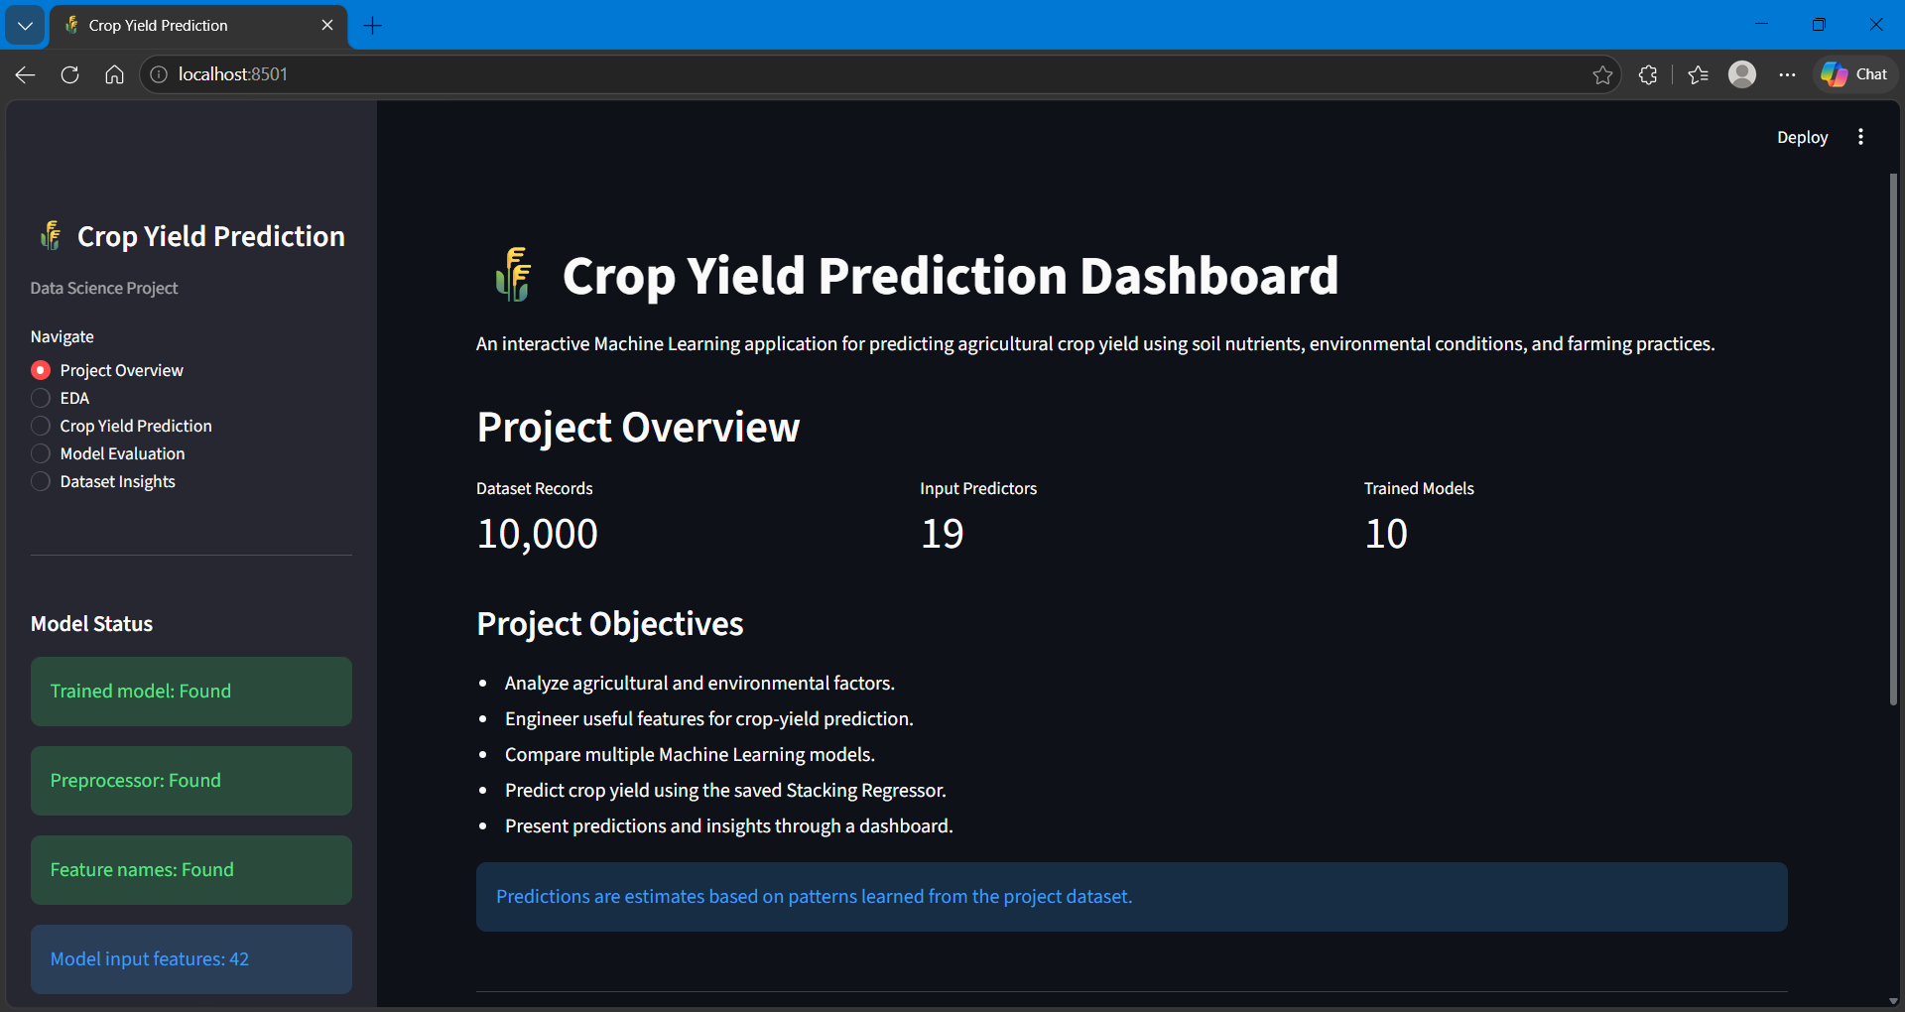

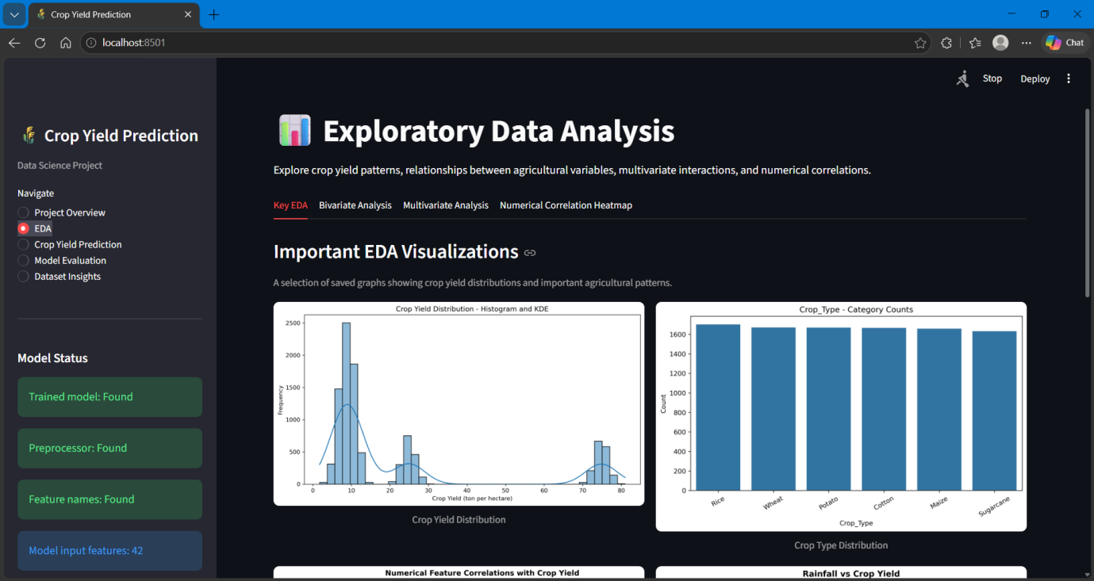

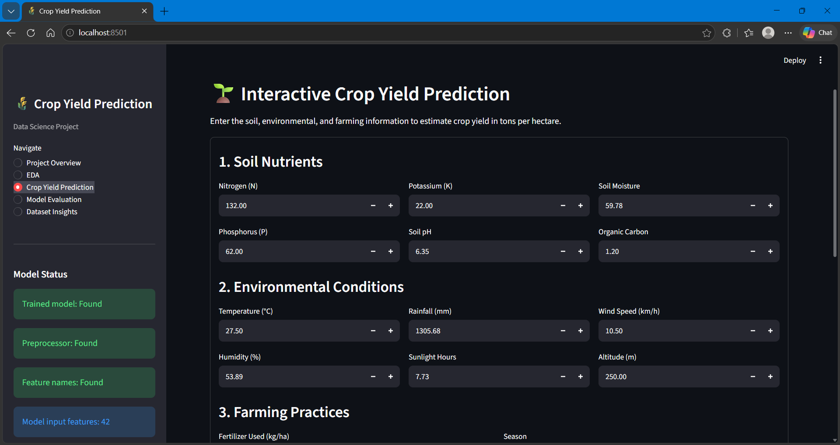

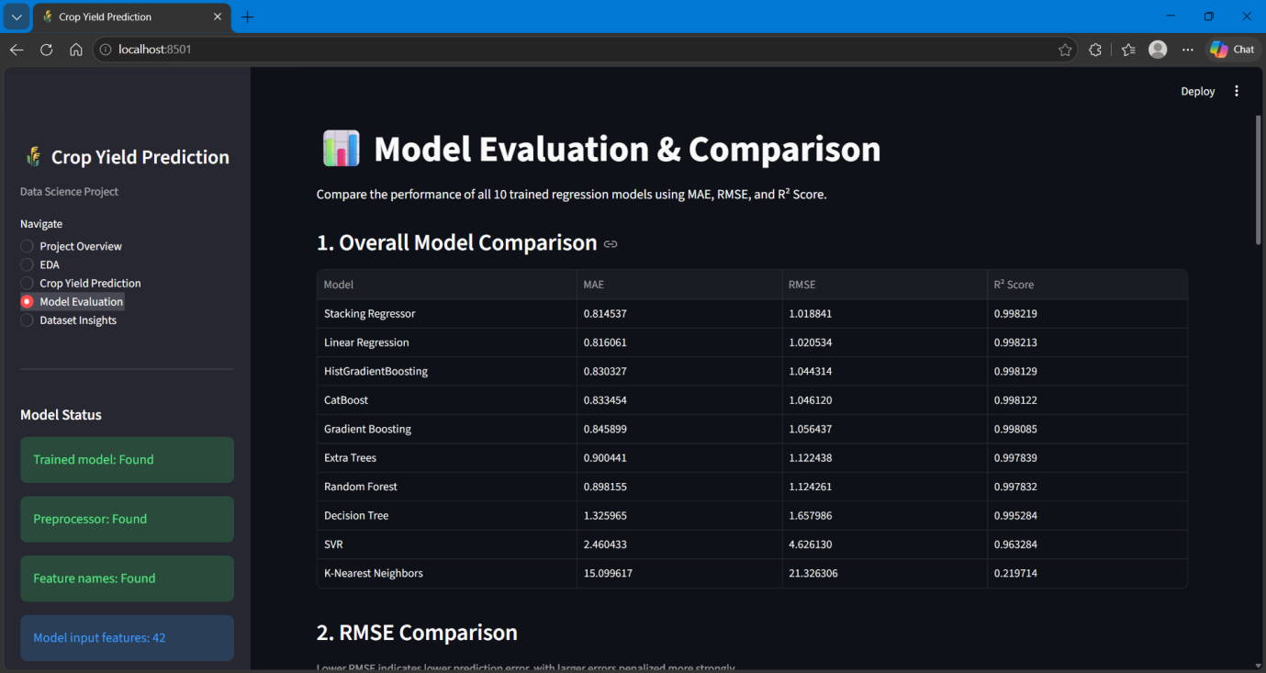

CHAPTER 8
Challenges and Limitations
8.1 Challenges Faced
During the development of the Crop Yield Prediction system, several challenges were encountered while handling agricultural data, developing machine learning models and integrating the prediction functionality into the dashboard.
The major challenges included:
1. Dataset Understanding: Understanding the relationships between soil properties, environmental conditions and agricultural practices required careful data exploration.
2. Data Preprocessing: Handling numerical and categorical features required different preprocessing techniques to prepare the dataset for machine learning algorithms.
3. Feature Engineering: Identifying meaningful combinations of existing agricultural variables and creating useful interaction features required experimentation.
4. Feature Selection: Selecting relevant features while retaining useful predictive information required evaluating different feature selection techniques.
5. Model Performance Comparison: Different regression algorithms produced varying results. Identifying suitable models required systematic evaluation using multiple performance metrics.
6. Ensemble Model Development: Combining multiple base models through a Stacking Regressor required configuring the base estimators, meta-learner and cross-validation strategy.
7. Dashboard Integration: Integrating the saved preprocessing pipeline and trained model into Streamlit while maintaining consistency between training and prediction workflows required careful implementation.
These challenges were addressed through systematic experimentation, validation and integration of the individual project components.
8.2 Solutions Applied
To overcome the challenges encountered during development, appropriate techniques and implementation strategies were applied at different stages of the project.
The following solutions were implemented:
1. Systematic Data Exploration: Examined dataset attributes, statistical summaries and visualizations to understand the agricultural and environmental variables.
2. Structured Preprocessing Pipeline: Used numerical imputation, categorical imputation, StandardScaler and OneHotEncoder through a ColumnTransformer to prepare the data consistently.
3. Feature Engineering: Created six additional features representing nutrient combinations, soil characteristics and interactions between environmental variables.
4. Feature Selection Techniques: Applied SelectKBest and Recursive Feature Elimination (RFE) to evaluate and select relevant features.
5. Comparative Model Evaluation: Developed and evaluated eleven regression models using multiple performance metrics, baseline comparisons and feature-ablation experiments.
6. Stacking Ensemble Implementation: Combined Linear Regression, Random Forest and Gradient Boosting as base estimators with Ridge Regression as the meta-learner.
7. Model and Dashboard Integration: Saved the trained model and preprocessing artifacts using Joblib and stored the final feature names in JSON format for consistent prediction through Streamlit.
These solutions helped establish a structured machine learning workflow and enabled the successful implementation of the interactive prediction dashboard.
8.3 Current Limitations
Although the Crop Yield Prediction system achieved strong predictive performance, certain limitations remain in its current implementation.
1. Dataset Dependency: The system uses a single Kaggle dataset containing 10,000 records. Its predictions are therefore limited by the quality, coverage and representativeness of the available data.
2. Limited Real-World Data: The system has not yet been validated using continuously collected field measurements or large-scale real-world agricultural observations.
3. No Real-Time Integration: Live weather information, soil sensors and IoT devices are not currently connected to the prediction system. Users must enter input values manually.
4. Generalization Across Regions: Agricultural conditions vary across geographical regions. The model's performance may differ when applied to locations or farming conditions not adequately represented in the training dataset.
5. Prediction-Based Estimates: The system provides estimated crop yield values based on learned data patterns. These predictions should not be treated as guaranteed actual harvest outcomes.
6. Limited Deployment: The current implementation is an interactive Streamlit application and has not yet been integrated into a large-scale agricultural management platform.
Addressing these limitations through broader datasets, real-world validation and external data integration could improve the system's applicability in practical agricultural environments.

CHAPTER 9
Future Scope
9.1 Dataset Expansion
The current system uses a single Kaggle dataset containing 10,000 records. In the future, the dataset can be expanded by incorporating agricultural information from multiple regions, crop varieties and farming conditions.
The following improvements can be considered:
- Multiple Data Sources: Integrate datasets from agricultural research institutions, government portals and other reliable sources.
- Regional Coverage: Include data from different geographical regions to improve the model's adaptability to varying agricultural conditions.
- Additional Crop Varieties: Expand the dataset to cover more crop types and their specific growing requirements.
- Historical Agricultural Data: Incorporate data collected across multiple growing seasons to study seasonal and long-term variations.
- Improved Data Quality: Include more comprehensive and reliable observations to strengthen model training and evaluation.
Expanding the dataset could help improve the model's generalization capability and make the prediction system more useful across diverse agricultural environments.
9.2 Advanced Machine Learning Techniques
The current system uses multiple regression algorithms and a Stacking Regressor to estimate crop yield. In the future, advanced machine learning and deep learning techniques can be explored to improve prediction performance and model adaptability.
The following enhancements can be considered:
- Advanced Ensemble Methods: Explore additional ensemble techniques such as Voting Regressors and advanced stacking configurations.
- Deep Learning Models: Experiment with neural networks and other deep learning architectures to identify complex relationships among agricultural variables.
- Hyperparameter Optimization: Apply techniques such as Bayesian Optimization and advanced search strategies to identify suitable model configurations.
- Explainable AI: Integrate techniques such as SHAP to understand the contribution of individual features to crop yield predictions.
- Model Optimization: Explore model tuning and optimization techniques to improve computational efficiency and predictive performance.
These enhancements could provide opportunities to further investigate model performance, interpretability and adaptability for crop yield prediction.
9.3 Real-Time Integration
The current system requires users to manually enter agricultural and environmental information to generate crop yield predictions. In the future, real-time data sources can be integrated to make the prediction process more automated and responsive.
The following enhancements can be considered:
- Weather API Integration: Connect weather APIs to retrieve real-time information such as temperature, humidity and rainfall.
- IoT Sensor Integration: Collect soil moisture, soil temperature and other field measurements through IoT-based sensors.
- Automated Data Collection: Develop mechanisms to collect and update agricultural data periodically.
- Live Prediction Updates: Use newly collected information to generate updated crop yield estimates.
- Cloud-Based Integration: Deploy the system on cloud infrastructure to support data storage, processing and remote access.
Real-time integration could reduce manual data entry and help make the system more useful for data-driven agricultural monitoring and decision-making.
9.4 Dashboard Enhancements
The current Streamlit dashboard provides project information, EDA visualizations, crop yield prediction, model evaluation and dataset insights. Further improvements can make the dashboard more interactive, informative and accessible.
The following enhancements can be considered:
- Advanced Visualizations: Introduce additional interactive charts to explore crop yield patterns and relationships between agricultural variables.
- Geographical Analysis: Include map-based visualizations to compare crop yield estimates across different regions.
- Prediction History: Provide an option to store and review previously generated predictions.
- User Authentication: Introduce secure login functionality to provide personalized access to dashboard features.
- Automated Reports: Generate downloadable reports containing prediction results, visualizations and relevant analytical insights.
- Mobile-Friendly Interface: Improve the dashboard layout to support convenient access across desktops, tablets and mobile devices.
These enhancements could improve the usability and accessibility of the system while supporting more comprehensive agricultural data analysis.

CHAPTER 10
Conclusion
10.1 Project Summary
The project "A Machine Learning Approach for Crop Yield Prediction Using Agricultural and Environmental Factors" focuses on developing a machine learning-based system to estimate crop yield using relevant agricultural and environmental information.
The project uses a Kaggle dataset containing 10,000 records and 20 attributes, including soil nutrients, soil properties, weather conditions, crop types and agricultural practices. A structured workflow was implemented, covering data preprocessing, exploratory data analysis, feature engineering, feature selection and machine learning model development.
Eleven regression models were evaluated using multiple performance metrics, baseline comparisons and feature-ablation experiments. Among the evaluated models, the Stacking Regressor achieved the best observed test performance, with an MAE of 0.814537, RMSE of 1.018841 and R² score of 0.998219.
Additionally, an interactive Streamlit dashboard was developed to provide project information, data visualizations, model evaluation results and crop yield predictions. The dashboard also supports downloading prediction results as CSV reports.
Overall, the project demonstrates how machine learning techniques can be applied to agricultural data to develop an interactive crop yield estimation system and support data-driven agricultural analysis.
10.2 Achievements
The project successfully achieved its major objectives through the development of a complete machine learning-based crop yield prediction system.
The key achievements include:
- Dataset Analysis: Successfully processed and analyzed a dataset containing 10,000 records and 20 attributes.
- Feature Engineering: Created six additional features to represent agricultural relationships and interactions.
- Feature Selection: Applied SelectKBest and Recursive Feature Elimination (RFE) to evaluate relevant features.
- Model Development: Implemented and compared eleven regression models for crop yield prediction.
- Ensemble Learning: Developed a Stacking Regressor combining Linear Regression, Random Forest and Gradient Boosting with Ridge Regression as the meta-learner.
- Model Performance: Achieved an MAE of 0.814537, RMSE of 1.018841 and R² score of 0.998219 using the Stacking Regressor on the test dataset.
- Comparative Experiments: Completed baseline comparisons and feature-ablation experiments to examine model performance.
- Interactive Dashboard: Successfully developed a Streamlit dashboard integrating data analysis, model evaluation and crop yield prediction.
- Report Generation: Implemented CSV download functionality to save prediction inputs and outputs.
These achievements demonstrate the successful completion of the project's major development, experimentation and implementation objectives.
10.3 Skills Learned
The development of this project provided practical experience in data science, machine learning and application development. It helped strengthen both technical and problem-solving skills through the implementation of a complete project workflow.
The major skills acquired include:
- Python Programming: Improved proficiency in Python for data analysis, preprocessing and machine learning implementation.
- Data Analysis: Gained experience using Pandas and NumPy to inspect, manipulate and analyze structured datasets.
- Data Visualization: Developed skills in creating meaningful visualizations using Matplotlib and Seaborn.
- Machine Learning: Gained practical knowledge of regression algorithms, ensemble learning and model evaluation.
- Feature Engineering and Selection: Learned to create meaningful features and evaluate their relevance using feature selection techniques.
- Model Evaluation: Developed an understanding of regression metrics, cross-validation, baseline comparisons and feature-ablation experiments.
- Application Development: Gained experience building interactive web applications using Streamlit.
- Model Deployment and Integration: Learned to save trained models and preprocessing artifacts using Joblib and integrate them into a prediction application.
- Problem-Solving: Improved the ability to identify implementation challenges, test solutions and develop a complete data-driven application.
Overall, the project provided valuable hands-on experience in applying data science and machine learning concepts to an agricultural prediction problem.

CHAPTER 11
References
[1] M. Abdel-Salam, N. Kumar, and S. Mahajan, “A proposed framework for crop yield prediction using hybrid feature selection approach and optimized machine learning,” Neural Computing and Applications, vol. 36, pp. 20723–20750, 2024.
[2] O. S. Nagesh, R. R. Budaraju, E.-S. M. El-Kenawy, M. Chopra, M. Jawarneh, and K. Kaliyaperumal, “Boosting enabled efficient machine learning technique for accurate prediction of crop yield towards precision agriculture,” Discover Sustainability, vol. 5, Art. no. 101, 2024.
[3] M. Ashfaq, I. Khan, A. Alzahrani, M. U. Tariq, H. Khan, and A. Ghani, “Accurate wheat yield prediction using machine learning and climate-NDVI data fusion,” IEEE Access, vol. 12, pp. 40947–40961, 2024.
[4] E.-S. M. El-Kenawy, A. Ibrahim, D. S. Khafaga, and M. M. Eid, “Predicting potato crop yield with machine learning and deep learning for sustainable agriculture,” Potato Research, 2024.
[5] M. N. Thimmegowda, K. N. Geetha, B. U. Choudhury, C. U. Srinivas, G. G. Eerappa, S. B. Yogananda, and H. M. Jayadeva, “Comparative analysis of machine learning and statistical models for cotton yield prediction in major growing districts of Karnataka, India,” Theoretical and Applied Climatology, 2025.
[6] M. A. Jabed and M. A. A. Murad, “Crop yield prediction in agriculture: A comprehensive review of machine learning and deep learning approaches, with insights for future research and sustainability,” Heliyon, vol. 10, no. 24, e40836, 2024.
[7] T. van Klompenburg, A. Kassahun, and C. Catal, “Crop yield prediction using machine learning: A systematic literature review,” Computers and Electronics in Agriculture, vol. 177, Art. no. 105709, 2020.
[8] S. M. Shawon, F. B. Ema, A. K. Mahi, F. L. Niha, and H. T. Zubair, “Crop yield prediction using machine learning: An extensive and systematic literature review,” Smart Agricultural Technology, vol. 10, Art. no. 100718, 2025.
[9] N. Parashar, P. Johri, A. A. Khan, N. Gaur, and S. Kadry, “An integrated analysis of yield prediction models: A comprehensive review of advancements and challenges,” Computers, Materials & Continua, vol. 80, no. 1, pp. 389–425, 2024.
[10] S. Vinson Joshua, A. Selwin Mich Priyadharson, R. Kannadasan, A. A. Khan, W. Lawanont, F. A. Khan, A. U. Rehman, and M. J. Ali, “Crop yield prediction using machine learning approaches on a wide spectrum,” Computers, Materials & Continua, vol. 72, no. 3, pp. 5663–5679, 2022.
[11] K. Jhajharia, P. Mathur, S. Jain, and S. Nijhawan, “Crop yield prediction using machine learning and deep learning techniques,” Procedia Computer Science, vol. 218, pp. 406–417, 2023.
[12] U. V. Nikhil, A. M. Pandiyan, S. P. Raja, and Z. Stamenkovic, “Machine learning-based crop yield prediction in South India: Performance analysis of various models,” Computers, vol. 13, no. 6, Art. no. 137, 2024.
[13] P. S. Maya Gopal and R. Bhargavi, “A novel approach for efficient crop yield prediction,” Computers and Electronics in Agriculture, vol. 165, Art. no. 104968, 2019.
[14] P. S. Maya Gopal and R. Bhargavi, “Performance evaluation of best feature subsets for crop yield prediction using machine learning algorithms,” Applied Artificial Intelligence, vol. 33, no. 7, pp. 621–642, 2019.
[15] S. Boppudi and S. Jayachandran, “Improved feature ranking fusion process with hybrid model for crop yield prediction,” Biomedical Signal Processing and Control, vol. 93, Art. no. 106121, 2024.
[16] Y. Wang et al., “Progress in research on deep learning-based crop yield prediction,” Agronomy, vol. 14, no. 10, Art. no. 2264, 2024.
[17] P. Muruganantham et al., “A systematic literature review on crop yield prediction with deep learning and remote sensing,” Remote Sensing, vol. 14, no. 9, Art. no. 1990, 2022.
[18] T. Hu et al., “Crop yield prediction via explainable AI and interpretable machine learning: Dangers of black box models for evaluating climate change impacts on crop yield,” Agricultural and Forest Meteorology, vol. 336, Art. no. 109458, 2023.
[19] Z. Li, Z. Nie, and G. Li, “Integrating crop modeling and machine learning for the improved prediction of dryland wheat yield,” Agronomy, vol. 14, no. 4, Art. no. 777, 2024.
[20] C. Kumar et al., “Multi-stage corn yield prediction using high-resolution UAV multispectral data and machine learning models,” Agronomy, vol. 13, no. 5, Art. no. 1277, 2023.
[21] P. Nevavuori et al., “Crop yield prediction using multitemporal UAV data and spatio-temporal deep learning models,” Remote Sensing, vol. 12, no. 23, Art. no. 4000, 2020.
[22] S. A. Shammi et al., “Application of UAV multispectral imaging to monitor soybean growth with yield prediction through machine learning,” Agronomy, vol. 14, no. 4, Art. no. 672, 2024.
[23] F. Liu et al., “Prediction models of growth characteristics and yield for Chinese winter wheat based on machine learning,” Agronomy, vol. 14, no. 4, Art. no. 839, 2024.
[24] L. F. Maldaner et al., “Predicting the sugarcane yield in real-time by harvester engine parameters and machine learning approaches,” Computers and Electronics in Agriculture, vol. 181, Art. no. 105945, 2021.
[25] E. Y. Obsie, H. Qu, and F. Drummond, “Wild blueberry yield prediction using a combination of computer simulation and machine learning algorithms,” Computers and Electronics in Agriculture, vol. 178, Art. no. 105778, 2020.
[26] R. Barzin et al., “Use of UAS multispectral imagery at different physiological stages for yield prediction and input resource optimization in corn,” Remote Sensing, vol. 12, no. 15, Art. no. 2392, 2020.
[27] M. F. Danilevicz et al., “Maize yield prediction at an early developmental stage using multispectral images and genotype data for preliminary hybrid selection,” Remote Sensing, vol. 13, no. 19, Art. no. 3976, 2021.
[28] V. Joshua, S. M. Priyadharson, and R. Kannadasan, “Exploration of machine learning approaches for paddy yield prediction in eastern part of Tamilnadu,” Agronomy, vol. 11, no. 10, Art. no. 2068, 2021.
[29] L. Breiman, “Random forests,” Machine Learning, vol. 45, pp. 5–32, 2001.
[30] D. H. Wolpert, “Stacked generalization,” Neural Networks, vol. 5, no. 2, pp. 241–259, 1992.

CHAPTER 12
Appendices
Appendices
The appendices contain supplementary materials that support the development, implementation and evaluation of the Crop Yield Prediction system. They provide additional evidence of the project work without interrupting the main report.
Appendix A — Saved Model Artifacts
The project uses the following saved artifacts:
File | Purpose
stacking_regressor_model.joblib | Stores the trained Stacking Regressor
preprocessor.joblib | Stores the fitted preprocessing pipeline
final_feature_names.json | Stores the final transformed feature names
Appendix B — Installation and Execution Guide
The project can be executed locally using the following steps:
- Clone or download the project repository.
- Open the project folder in Visual Studio Code.
- Create and activate a Python virtual environment if required.
- Install the required Python libraries using the project's dependency list.
- Ensure the dataset and saved model artifacts are available in their respective folders.
- Open the terminal in the project root directory.
- Run the following command:
streamlit run app.py
8. Open the local URL displayed in the terminal to access the dashboard.

